
Soft_Solutions4U
Quality System Procedure

Training Manual Template Volume 12 Version No. 1.2 Effective from 12 may
may 12 2010.



Configuration of VNC Server

Prepared By (SS4U) | Signature | R.MARIKKANNAN
Prepared By (SS4U) | Name | R.MARIKKANNAN
Reviewers | Signature
Reviewers | Name
Approvers | Signature
Approvers | Names

Soft_Solutions4U
Quality System Procedure

Training Manual Template Volume 12 Version No. 1.2 Effective from 12 may
may 12 2010.

VNC SERVER CONFIGURATION

Step:1

Installation of VNC Server by using the following command

# yum install vnc*;

Step:2

Go to configuration file of vncserver by using the following path

# vim /etc/sysconfig/vncservers

at last you make the following changes

VNCSERVER=”1”
VNCSERVERARGS[1]=”geometry 1024x768 -depth 16”

And then go to the following files and make the following changes in that file.

# vim ~/.vnc/xstartup

here you uncomment the following lines

unset SESSION_MANAGER
exec /etc/X11/xinit/xinitrc

Soft_Solutions4U
Quality System Procedure

Training Manual Template Volume 12 Version No. 1.2 Effective from 12 may
may 12 2010.

Step:3

Password Creation for vncserver:

#vncpasswd
passwd:
verify:

Step:4

Start the vnc server by using the following command

#vncserver :1

Stop the service by using the following command

#vncserver -killall:1

Step :5

To access the remote desktop by using the following command

#vncviewer -Shared 192.168.2.66:1

it will ask password

Soft_Solutions4U
Quality System Procedure

Training Manual Template Volume 12 Version No. 1.2 Effective from 12 may
may 12 2

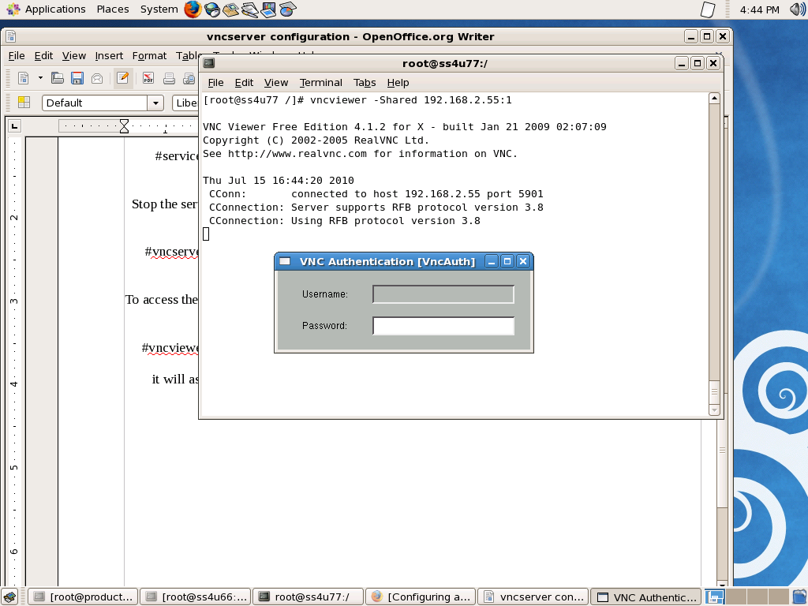

and you enter the the correct password,you will show the remote desktop

Soft_Solutions4U
Quality System Procedure

Training Manual Template Volume 12 Version No. 1.2 Effective from 12 may
may 12 2010.

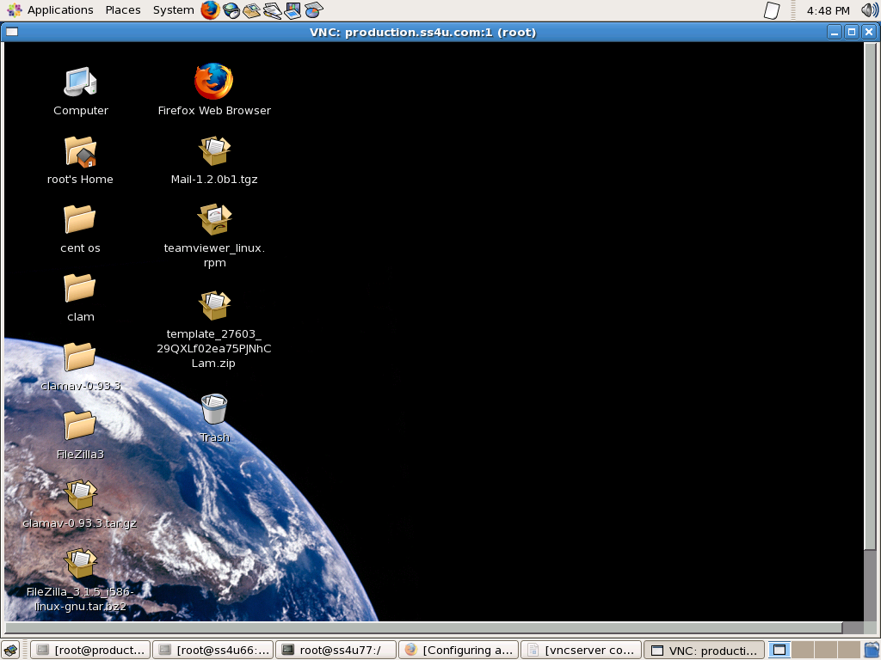

Now you can access the remote desktop,here you can access the files as like your monitor.

